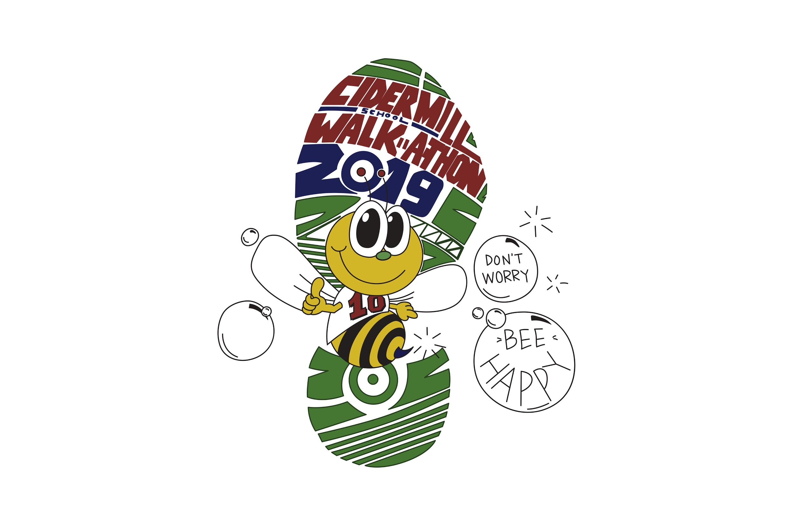

**Cider Mill Walkathon 2019**

Child’s Name

Teacher

T-shirt Size (if form returned by 9/25)

YS YM YL YXL

Donation Amount (Checks payable to: Cider Mill PTA)